Instructions for adding Speak tool to Quick Access Toolbar:
- Click the arrow in the Quick Access Toolbar.
- Select More Commands
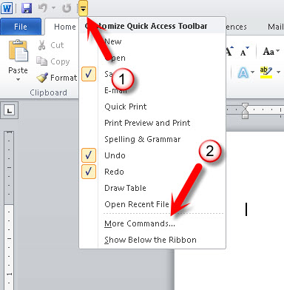

- Click the Poplar Commands option.
- Select All Commands from the commands list.
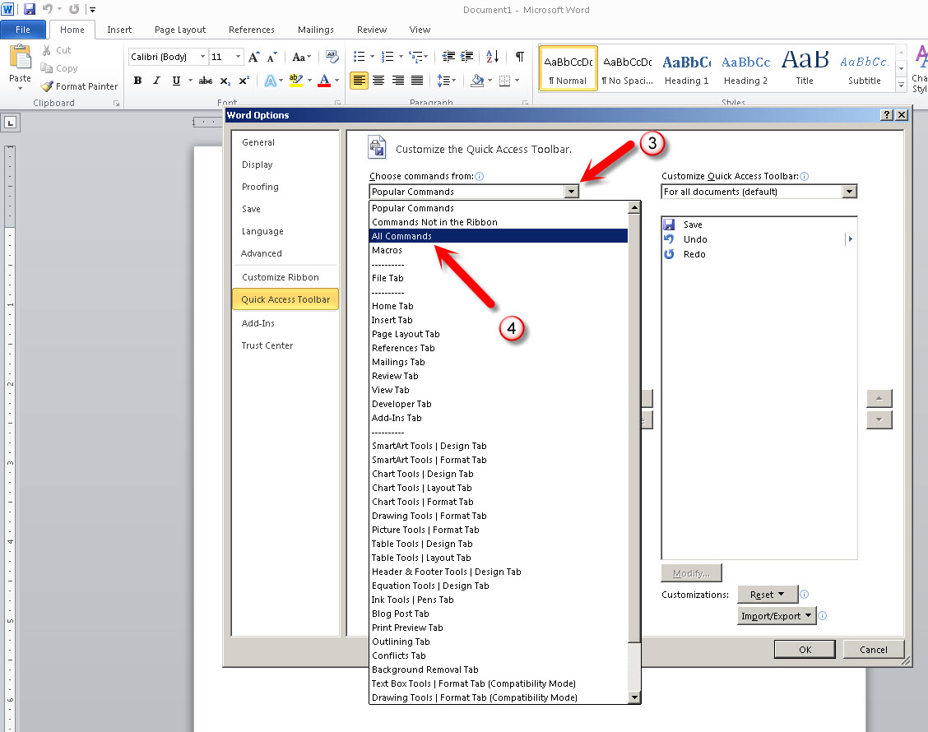

- Select the Speak tool from the list.
- Click the Add>> button
- You should now see Speak in the Quick Access Toolbar list.
- Click OK to complete the installation.
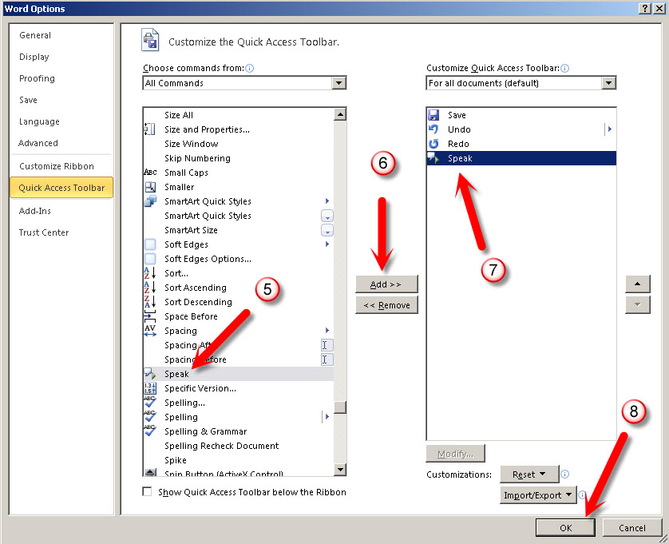

- Highlight the text that needs to be read aloud.
- Click the Speak icon in the toolbar to have the text read aloud.

