IPHONE & iPad

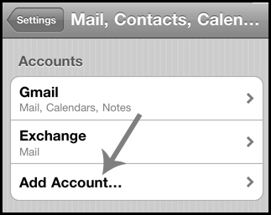
- Press the "Settings" app icon.

- Press Mail, Contacts, Calendars.

- Press Add Account…

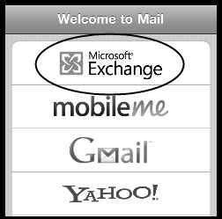

- Press, Microsoft Exchange to set up a new Exchange account.

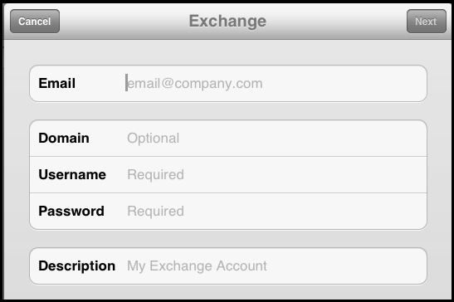
- In the fields type the Cabarrus County School’s Microsoft Exchange account information for the account.

  - Email: type full email address
Example: jennifer.jenkins@cabarrus.k12.nc.us

  - Domain: ccs.k12.int

  - Username: type the first part of the email address.
Example jennifer.jenkins

  - Password: type the email password for the account.

- Tap the NEXT button. Top right corner of Account Information window.

- There will be a pause while the account information is verified.

- If prompted type the Server information: webmail2.cabarrus.k12.nc.us

- Tap Done.

- Press Home button.

